Reading:
The children will be able read books matched to their colour book band (Bug Club)
The children will be able to answer questions about the book they have read (Bug Club)
Phonics:
The children will be able to blend words to read matched to their phonic ability e.g., ex- pl- ode (practise reading words sent via Purple Mash)
Writing:
The children will learn to about a traditional tale for Russia.
The children will be able to add the suffix ed and ing.
The children will learn to use prepositional language to describe the position of things e.g. next to. opposite, above, below, beneath.
Maths:
To represent and interpret data.
 | 9:00-9:10 | 9:30-10:30 | PE/Brain Break Super Movers | 11:00--12:00 | Lunchtime 12:00-1:00 | 1:00-1:45 | 2:00-2.45 | 2.40 – 2.55
Monday | Microsoft Teams  Morning Welcome | JIGSAW  Healthy Me  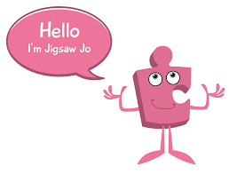  What do we need to keep healthy?  Can you make a list or draw all the ways you can think of to stay healthy?  Jigsaw Jo does not want to go to bed.  How could you motivate her?  What would happen if Jigsaw Jo went to bed late? |  | MATHEMATICS  Maths National Academy Year 2 Maths –  Topic: Graphs  https://classroom.thenational.academy/units/graphs-a428  Lesson 1  Representing and Interpreting data using a pictogram.  OR  https://classroom.thenational.academy/units/graphs-a428  Lesson 2 (Challenge)  Representing and Interpreting data using a block diagram and a table. |  | ENGLISH  Bug club Link: https://www.activelearnprimary.co.uk/login?c=0  Reading comprehension – answer questions about the books you are reading.  Complete SPaG activity.  Practise words to read and spellings. | PHYSICAL EDUCATION  https://www.bbc.co.uk/teach/supermovers/pshe-super-mood-movers-being-happy-and-safe/z6q3sk7  Get moving with Super Movers!  Being happy and safe.  How do you keep safe? | STORY TIME
Tuesday | Morning Welcome | MATHEMATICS  National Academy Year 2 Maths –  Topic: Graphs  https://classroom.thenational.academy/units/graphs-a428  Lesson 3  Representing data in a tally chart and pictogram. |  | ENGLISH  National Academy Year 2  Link: https://classroom.thenational.academy/lessons/listen-to-a-story-and-answer-questions-ccukcd  Topic: Baba Yaga - Openings  Lesson: 1: Listen to a story and answer questions. |  | DESIGN & TECHNOLOGY  FOOD  Working with an adult, can you design and make a food product for your family e.g. a sandwich, a vegetable snake, a fruit face.  If possible, please take a photo to show us.  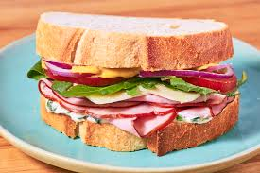  Ask your family for some feedback on your product?  What did they think about the taste, smell, texture, and appearance? | RELIGIOUS EDUCATION  Special books  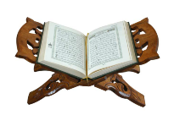  What have you learned about words that are special to Muslims and Christians?  Is there someone to whom you would like to say some special words?  Make a card with one word on it and give it to someone you would like to have that word. | STORY TIME
Wednesday | Microsoft Teams  Morning Welcome | MATHEMATICS  National Academy Year 2 Maths  Topic: Graphs  https://classroom.thenational.academy/units/graphs-a428  Lesson 4  Representing data in a tally chart and block diagram. |  | ENGLISH  National Academy Year 2  Link: https://classroom.thenational.academy/lessons/to-tell-a-story-from-memory-6ngk0e  Topic: Baba Yaga - Openings  Lesson: 2 – To tell a story from memory. |  | GEOGRAPHY  Topic: Continents  Africa  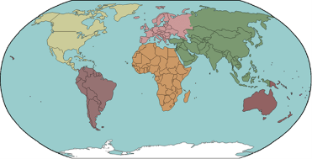  Share the PowerPoint about Africa emailed to you on Purple Mash.  Using your new knowledge make an Information page all about Africa with pictures and captions.  What is Fair Trade?  Watch a video clip about Fair Trade on Espresso. This has been assigned to you. | MUSIC  National Academy Year 2 Music  Link: https://classroom.thenational.academy/lessons/identifying-strong-beats-c4wkec  Topic: Pulse  Lesson: 6  How many beats in a bar?  Can you listen to your favourite song and count the beat? | Story Time  Come and join us for story time on Microsoft TEAMS
Thursday |  | MATHEMATICS  National Academy Year 2 Maths  Topic: Graphs  https://classroom.thenational.academy/units/graphs-a428  Lesson 5  Interpreting data from scaled pictograms and block graphs. |  | ENGLISH  National Academy Year 2  Link: https://classroom.thenational.academy/lessons/to-develop-detail-in-the-opening-scene-cdhk2r  Topic: Baba Yaga - Openings  Lesson 3: To develop detail in opening the scene. |  | HISTORY  Share the power point,  emailed to you on purple mash.  Apollo Moon Landing  Act out being one of the Apollo 11 astronauts: take off, fly through space, and land on the moon.  What is the famous statement that Neil Armstrong said when he stepped onto the moon for the first time? | PHYSICAL EDUCATION  https://www.bbc.co.uk/teach/supermovers/pshe-super-mood-movers-being-happy-and-safe/z6q3sk7  Get moving with Super Movers!  Being happy and safe.  How do you keep safe? | STORY TIME
Friday | Microsoft Teams  Morning Welcome | SCIENCE  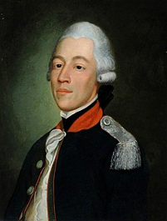  What can you find out about Charles Mackintosh?  What is he famous for inventing?  PARENT/CARER SUPPORT NEEDED  Ask an adult if you can use some clothes or fabric from inside your home.  We are learning about waterproofing. Are any of the fabrics waterproof? How can you test? How can you make the test fair?  How will you record your findings? |  | ENGLISH  National Academy Year 2  Link: https://classroom.thenational.academy/lessons/to-use-prepositional-phrases-of-place-c5j62d  Topic: Baba Yaga - Openings  Lesson 4: To use prepositional phrases of place. |  | MATHEMATICS  Purple Mash  Check your 2dos.  Have you completed all your tasks on Mathletics and Purple Mash? | GOLDEN TIME  Have you followed our golden rules at home this week?  Have you worked hard?  Have you been kind and helpful?  Choose your own activity and have fun! | STORY TIME  Have a nice weekend. See you on Microsoft Teams on Monday morning!

