Learning Objectives for the week:
Reading:
To join in with the repeated phrases from ‘We’re going on a bear hunt’.
Phonics:
To sort pictures that rhyme.
To hear the sound ‘t’ in cvc words.
Writing:
To draw their face and body parts that are in the right proportions.
To use their name card (that went home at Christmas) to practise copying letters from their name. (Please encourage your child to do this daily)
Maths:
To recognise the number 7 and recite numbers 1-7.
DAY & TIME | REGISTRATION  AM group- 9:30-9:40  PM group-  12:30-12:45 | ADULT LED  AM group- 9:40-9:50  PM group- 12:45-13:00 | CIL  AM group-  9:50-10:30  PM group-  13:00-14:00 | MOVEMENT BREAKS  AM group-10:30-10:40  PM group-  14:00-14:10 | PHONICS  10.50-11.00/ 14:20-14:30 SNACK TIME  AM group-  10:40-10:50  PM group-  14:10-14:20 |  | STORY TIME  AM group- 11:00-11:15  PM group-  14:30-14:45
Monday | JOIN MICROSOFT TEAMS FOR SESSION WELCOME  Days of the week &  Weather song. | EAD & WRITING  LO: To create a stick puppet of myself.  Adult to model drawing ourselves first to remind what we need to draw for our body.  Example questions: What shape shall I use for my head and eyes? What else do I need to make my face?  Support cutting out the puppet and join onto a lollypop stick, chopstick or straw etc. to create a prop for our story this week where we will be going on a bear hunt!  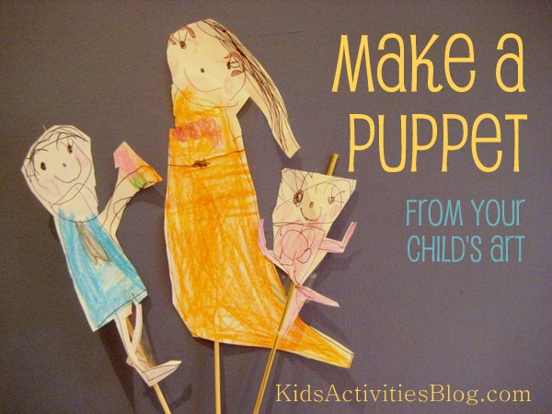 | CHILD INITIATED LEARNING  The children can choose their own toy/learning activity. For example Jigsaws, drawing, painting, reading, role play, purple mash etc.  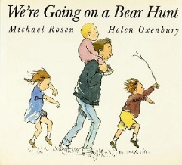  10:15 –JOIN MICROSOFT TEAMS FOR GROUP STORY. | MOVEMENT BREAKS BETWEEN ACITIVITIES  Children copy the actions to the songs using The Learning Station.  Herman the Worm-  https://www.youtube.com/watch?v=0-rg7EIt1x4 | FAVOURITE STORY  Can they copy any animal noises? Can they describe the setting and character?  SNACK TIME  Can they join in with repeated phrases? |  | STORY TIME  Join Microsoft Teams for a group story.
Tuesday | JOIN MICROSOFT TEAMS FOR SESSION WELCOME  Days of the week &  Weather song. | READING  Lesson: To join in with the repeated phrases in the Bear Hunt story.  Listen to the Bear Hunt story and support joining in with the repeated phrase “we can’t go over it, we can’t go under it. We’ll have to go through it!”  Use your stick puppet from Monday to go on a Bear Hunt around your garden.  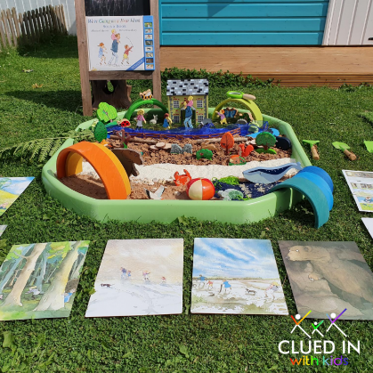  LINK-  https://www.youtube.com/watch?v=2OI7fe766n | CHILD INITIATED LEARNING  The children can choose their own toy/learning activity. For example Jigsaws, drawing, painting, reading, role play, purple mash etc. | MOVEMENT BREAKS BETWEEN ACITIVITIES  Children copy the actions to the songs using The Learning Station.  Move & freeze-  https://www.youtube.com/watch?v=388Q44ReOWE | NURSERY RHYMES  Nursery rhymes- https://www.bbc.co.uk/teach/school-radio/nursery-rhymes-songs-index/zhwdgwx  Can they sing along with their favourite Nursery rhymes?  SNACK TIME  Can they sing a favourite Nursery rhyme  independently?  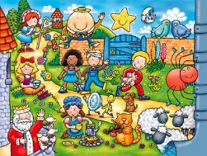  Can they add actions to the Nursery rhymes? |  | STORY TIME  Choose your favourite story to read with your family.
Wednesday | JOIN MICROSOFT TEAMS FOR SESSION WELCOME  Days of the week &  Weather song. | MATHS - TEN TOWN  Listen to Sir Seven’s story and song.  (Use log in details that have been sent over Purple Mash email).  https://www.tentown.co.uk/sign_in.php  Just like Sir Seven, can you count out 7 of your favourite toys?  Have a go at writing the number 7 using Sir Seven’s rhyme.  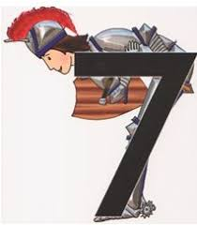  “Across his back, bend down to his feet, take your time and keep it neat”. | CHILD INITIATED LEARNING  The children can choose their own toy/learning activity. For example Jigsaws, drawing, painting, reading, role play, purple mash etc. | MOVEMENT BREAKS BETWEEN ACITIVITIES  Children copy the actions to the songs using The Learning Station.  Boom chicka boom-  https://www.youtube.com/watch?v=69f9sCwhwYk | RHYME  Play the Cake Bake game exploring pictures of objects that rhyme.  Put all the pictures that rhyme in the mixing bowl to make a special cake.  SNACK TIME  LINK- https://www.phonicsplay.co.uk/resources/phase/1/cake-bake |  | STORY TIME  Choose your favourite story to read with your family.
Thursday | JOIN MICROSOFT TEAMS FOR SESSION WELCOME  Days of the week &  Weather song. | EAD  Lesson: To join materials and build the bears cave from the bear hunt story.  You could use duplo, toy bricks, papier mache or cardboard boxes.  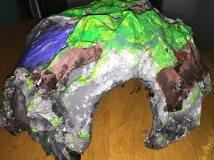  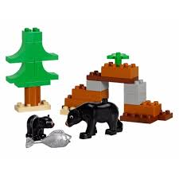  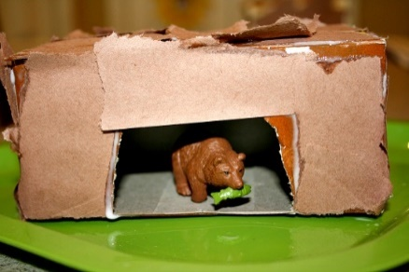 | CHILD INITIATED LEARNING  The children can choose their own toy/learning activity. For example Jigsaws, drawing, painting, reading, role play, purple mash etc. | MOVEMENT BREAKS BETWEEN ACITIVITIES  Children copy the actions to the songs using The Learning Station.  Get Funky-  https://www.youtube.com/watch?v=EoGcLbOEOdc | SILLY SOUP  Watch the video and help Felix make silly soup by putting in all the pictures that rhyme.  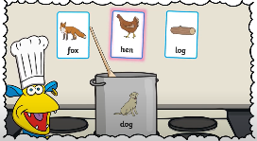  LINK-  https://www.youtube.com/watch?v=1KHrgXrlyH8  Can you sing along with the Nursery rhymes?  Will you have a go at making Incy Wincy spider? |  | JOIN TEAMS FOR SHOW AND TELL  SNACK TIME
Friday | JOIN MICROSOFT TEAMS FOR SESSION WELCOME  Days of the week &  Weather song. | PHYSICAL DEVELOPMENT  Warm up-  Listen and join in with:  Funky Monkey-  https://www.youtube.com/watch?v=U9aBYLRhFW8  Bend & Stretch-  https://www.youtube.com/watch?v=S3UwfdiyApI  Do they notice anything different about themselves after warming up? (Feeling hot, red cheeks and heart beating faster).  Andy’s Wild Workouts-  Can you copy Andy’s actions?  Can you make up your own actions for one of the animals?  LINK-  https://www.bbc.co.uk/iplayer/episode/p06tmrxh/andys-wild-workouts-series-1-10-arctic | CHILD INITIATED LEARNING  The children can choose their own toy/learning activity. For example Jigsaws, drawing, painting, reading, role play, purple mash etc. | MOVEMENT BREAKS BETWEEN ACITIVITIES  Children copy the actions to the songs using The Learning Station.  Shake your sillies out-  https://www.youtube.com/watch?v=NwT5oX_mqS0 | LETTERS AND SOUNDS  SNACK TIME  Watch the video about the sound ‘t’. Can you hear the letter ‘t’ in any of the words?  LINK-  https://www.bbc.co.uk/iplayer/episode/p087310l/alphablocks-magic-words-20-meet-alphablock-t  Here are some phonics resources on Purple Mash and Phonics Play to support learning ‘satpin’ and Phase 2 phonics.  https://www.purplemash.com/#tab/pm-home  https://www.phonicsplay.co.uk/ |  | STORY TIME  Choose your favourite story to read with your family.

