Learning Objectives for the week: (Please check purple mash emails to find out which colour group your child is in ready for Microsoft Teams)
Reading:
The children will be able to describe the troll and use actions to retell the story of ‘The Three Billy Goats Gruff”

Phonics:
The children will recognise the letters qu,sh,ch and read words with these sounds.
The children will be able to read their word set.
The children will be able to recognise the tricky word was.

Writing:
The children with support will be able to write a simple sentence for a picture.
The children will be able to write their first name and surname in cursive letters.(Please encourage your child to write their name daily)

Maths:
The children will be able to order 3 numbers from the least value to the greatest value.
The children will be able to say 1 more than a number to 15.
 | Registration  9:10-9:20  Microsoft Teams all children to attend registration | 9:20-9:40 | 9:40-10:30 | Brain Break https://www.bbc.co.uk/teach/supermovers/ks1-collection/zbr4scw | 11:00--12:00 | Lunchtime 12:00-1:20 | 1:20-2:00  Review of learning  Class Teacher to call groups of children on Microsoft Teams. | 2:00-2:45  Review of learning  Class Teacher to call groups of children on Microsoft Teams. | 2:45-3:00
Monday | Microsoft Teams  Morning Welcome  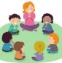 | Phonics  Link: https://www.youtube.com/watch?v=WyeO5KFNtZU  Lesson: 39 part 1 | Reading  Phonics Play  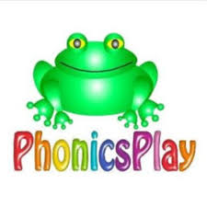  Link: https://www.ictgames.com/mobilePage/bingo/index.html  Blending bingo (Phase 2/3) |  | Reading  Bug club : Read Books and words  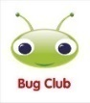 |  | Understanding The World  Oak Academy  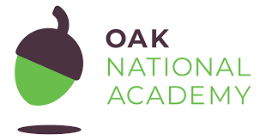  Link: https://classroom.thenational.academy/lessons/to-understand-how-humans-react-differently-to-hot-and-cold-6tj32d  Lesson: Winter: Hot/Cold  To understand how humans react differently to hot and cold  Microsoft Teams  Reading Review of Learning- Word sets (Individually)  1:20- 2:00 Yellow group  2:00- 2:40 Green group | CHILD INITIATED LEARNING  The children can choose their own toy/learning activity | Story Time  Pick your favourite story or read your school books
Tuesday | Microsoft Teams  Morning Welcome  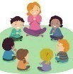 | Phonics  Link: https://www.youtube.com/watch?v=NDP0vXcs0Hw  Lesson: 39 part 2 | Literacy  Oak Academy  https://classroom.thenational.academy/lessons/to-step-the-story-cmrk6c  Lesson: The Three Billy Goats Gruff: Lesson 3:  To step the story |  | Reading  Phonics Game (2do) |  | Art  Can you make your own Billy Goat using junk modelling?  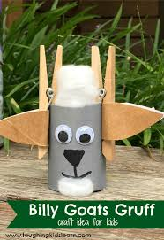 | CHILD INITIATED LEARNING  The children can choose their own toy/learning activity  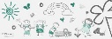  Microsoft Teams  Writing Review of Learning  2-2:15 Yellow group  2:15-2:30 Green group | Story Time  Pick your favourite story or read your school books
Wednesday | Microsoft Teams  Morning Welcome | Phonics  Link:  https://www.youtube.com/watch?v=tuzFWRkKh8A  Lesson: 41 part 1 | Maths  Oak Academy  Link: https://classroom.thenational.academy/lessons/counting-up-to-15-objects-and-putting-them-in-order-part-3-60v6cc  Lesson: Numbers within 15  Lesson 3:  Counting up to 15 objects and putting them in order (Part 3) |  | Maths  Mathletics activity  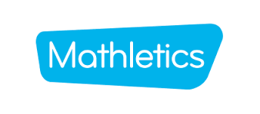 |  | PSHE  Oak Academy  Link: https://classroom.thenational.academy/lessons/were-part-of-the-same-pond-68t6ad  Lesson: A new Normal lesson 2  We're part of the same pond | CHILD INITIATED LEARNING  The children can choose their own toy/learning activity  Microsoft Teams  Maths Review of Learning  2-2:15 Yellow group  2:15-2:30 Green group | Story Time  Pick your favourite story or read your school books
Thursday | Microsoft Teams  Morning Welcome  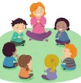 | Phonics  Link: https://www.youtube.com/watch?v=U2mlqh3OVAk  Lesson: 41 part 2 | Literacy  Oak Academy  https://classroom.thenational.academy/lessons/to-mime-the-story-of-the-three-billy-goats-gruff-70w62e  Lesson: The Three Billy Goats Gruff: Lesson 4:  To mime the story of The Three Billy Goats Gruff |  | Reading  Bug club : Read Books  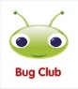 |  | Computing  Purple Mash  Winter scene (2do) | CHILD INITIATED LEARNING  The children can choose their own toy/learning activity  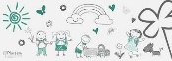 | Story Time  Pick your favourite story or read your school books
Friday | Microsoft Teams  Morning Welcome  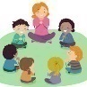 | Phonics  Link: https://www.youtube.com/watch?v=7fE27v8n7Vw  Lesson: 42: piece 1 | Maths  Oak Academy  https://classroom.thenational.academy/lessons/knowing-one-more-than-a-number-within-15-60up8r  Lesson: Knowing one more than a number within 15: Lesson 4: |  | Maths  Mathletics activity |  | Music  Oak Academy  Link: https://classroom.thenational.academy/lessons/good-to-be-me-64u3jd  Lesson: Good to be me | GOLDEN TIME  Activity of choice | Story Time  Pick your favourite story or read your school books

